DELHI TECHNOLOGICAL UNIVERSITY
(Formerly Delhi College of Engineering) Shahbad Daulatpur, Bawana Road, Delhi-110042

DEPARTMENT OF COMPUTER SCIENCE AND ENGINEERING

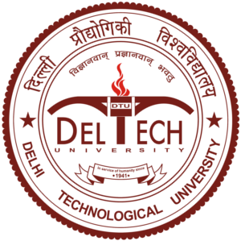

Lab Name: IPM Lab
CS207 : Operating System

Submitted to:
Dr. Gunjan Chug
Assistant Prof.
CSE Dept.
Submitted By :
Sonu Yadav
25/CS/407
B.Tech CSE 2nd Year Semester-3
CSE-6 (G3)

